for $x in doc("menu3")//PLATO[@category="POSTRE"]

return $x

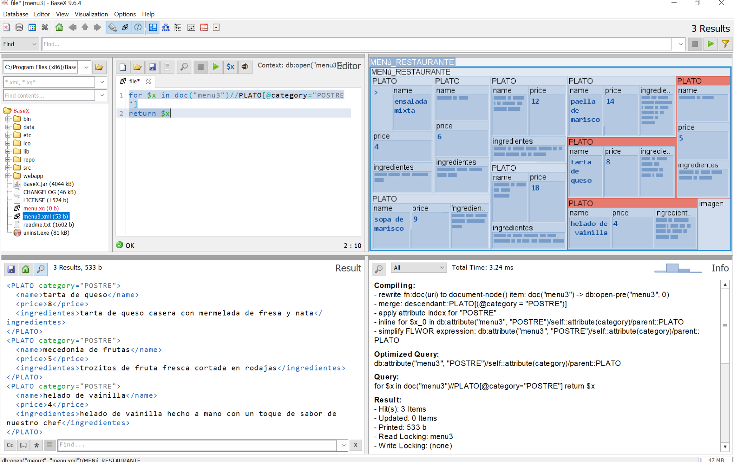

for $x in doc("menu3")//PLATO[price<10]

return $x

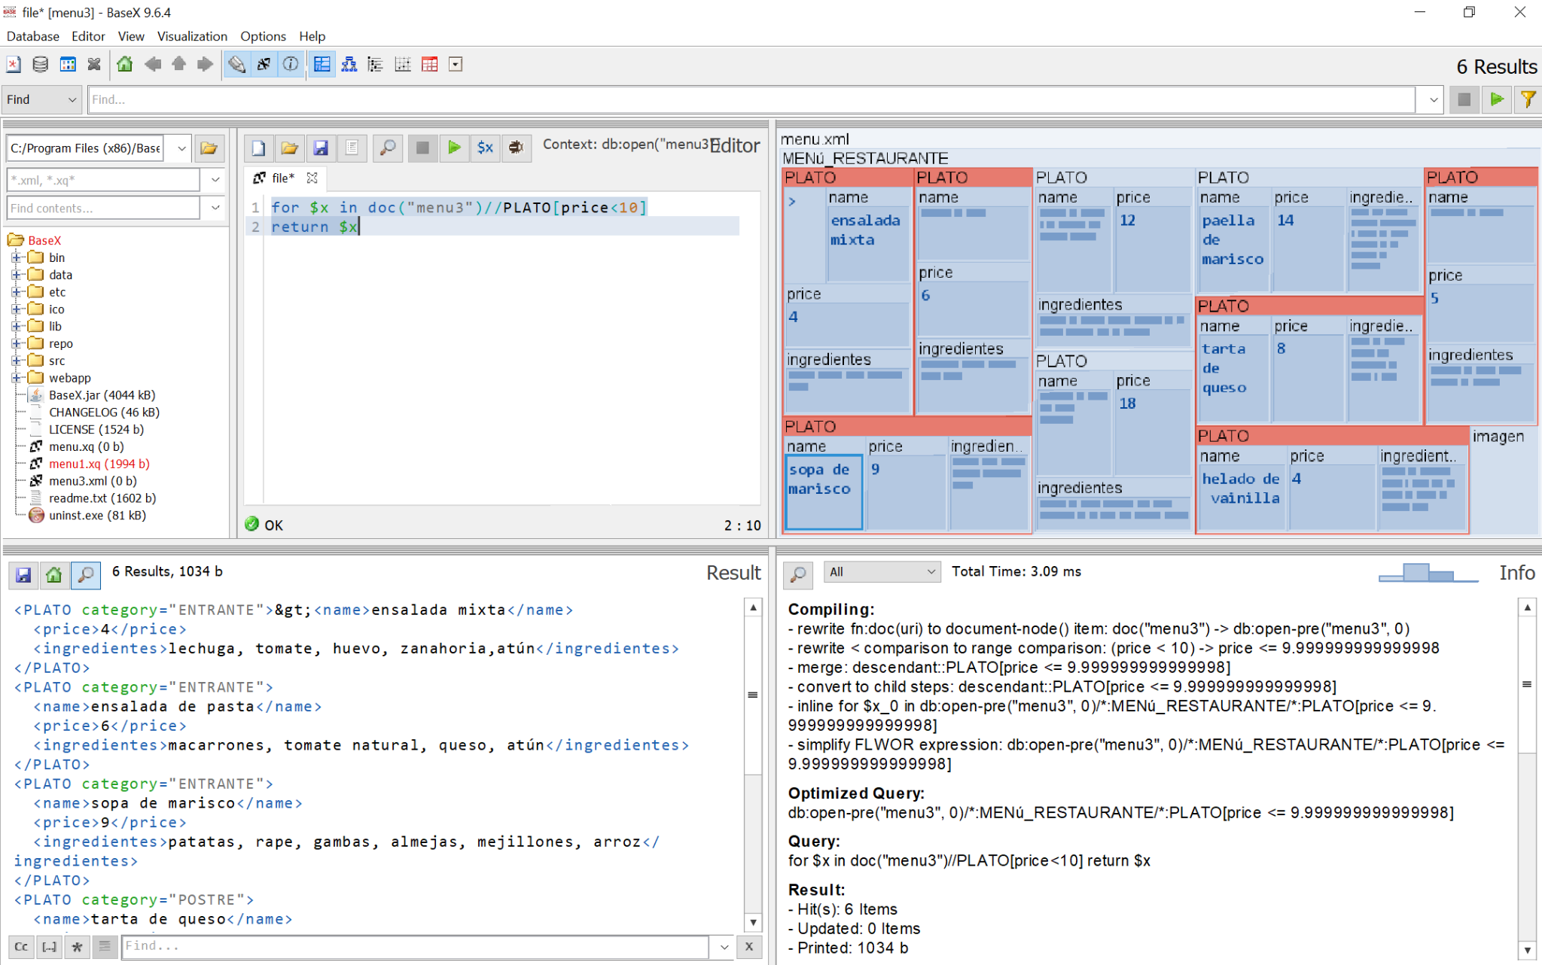

for $x in doc (“menu”)// INGREDIENTES = pescado

return $x

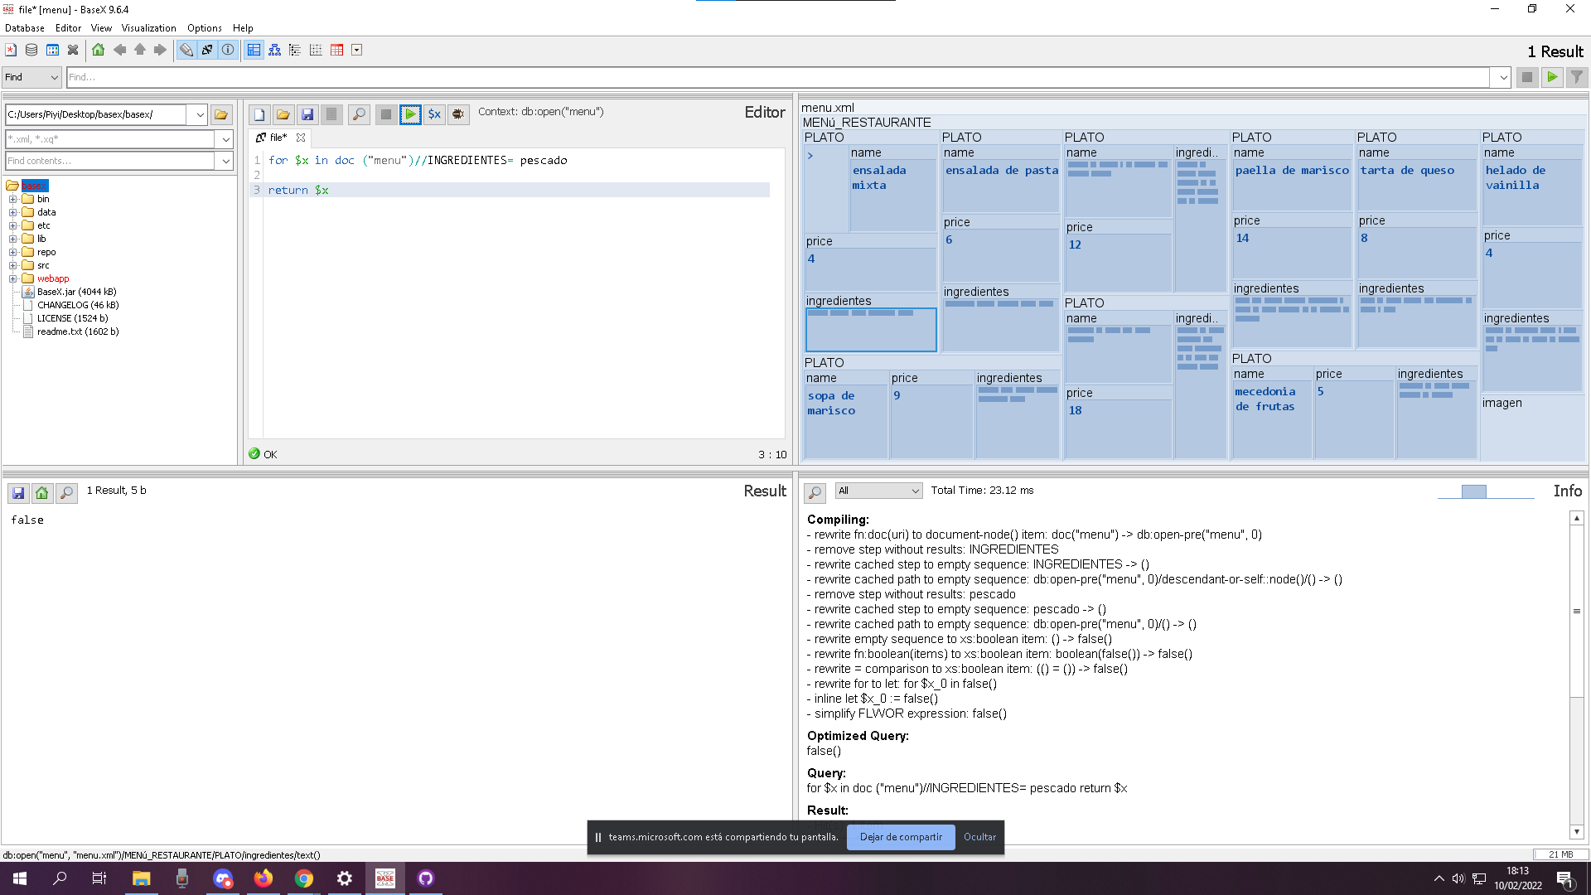

for $x in doc (“menu”)//PLATO[last()]

return $x

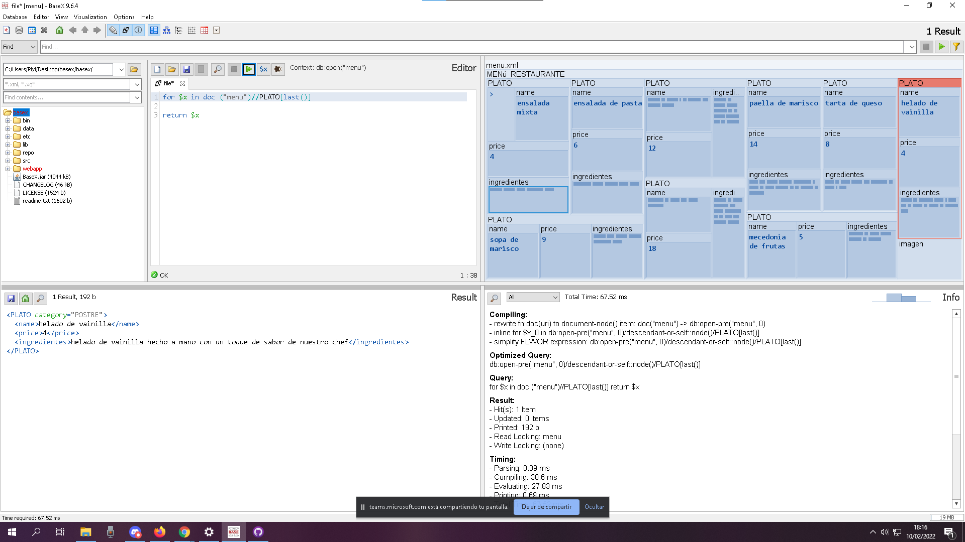

for $x in doc(“menu”)//name

return $x

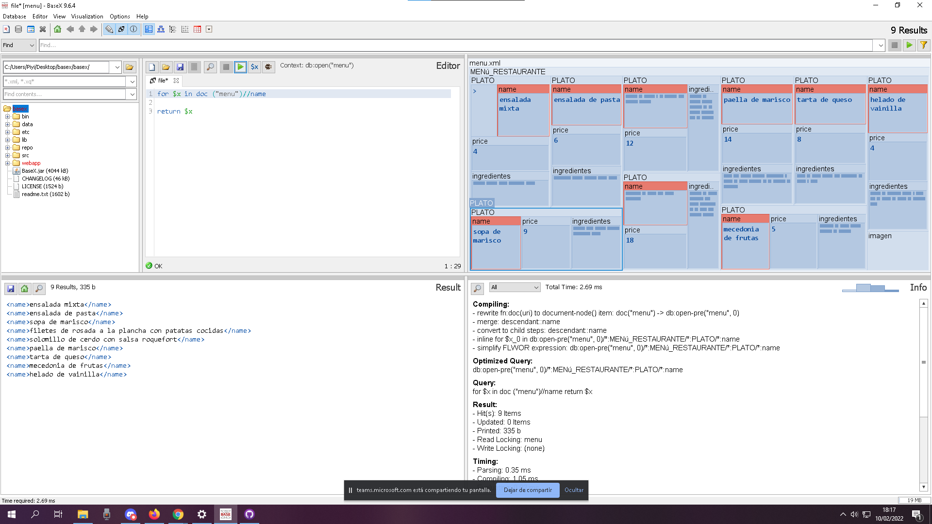

3 OPCIONALES

for $x in doc (“menu”)//name | //ingredientes [position()=1]

return $x

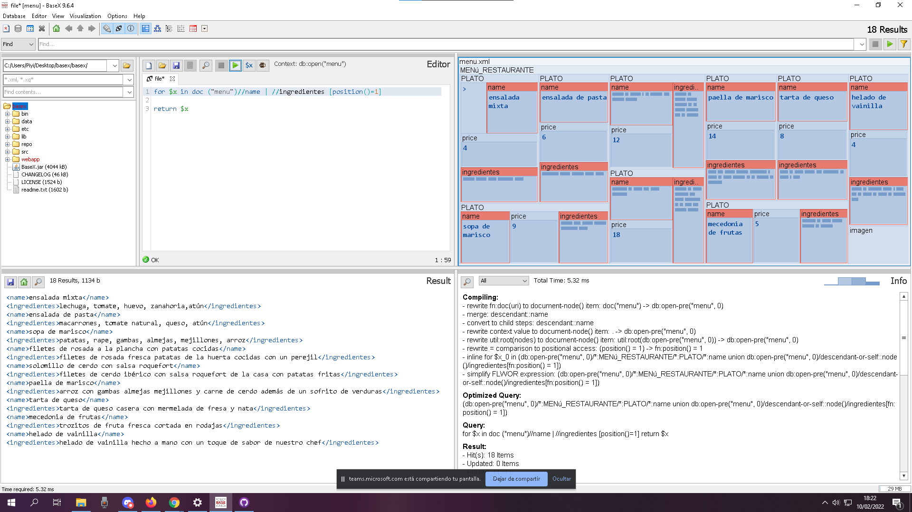

for $x in doc (“menu”)//PLATO[@category=’ENTRANTE’]

return $x

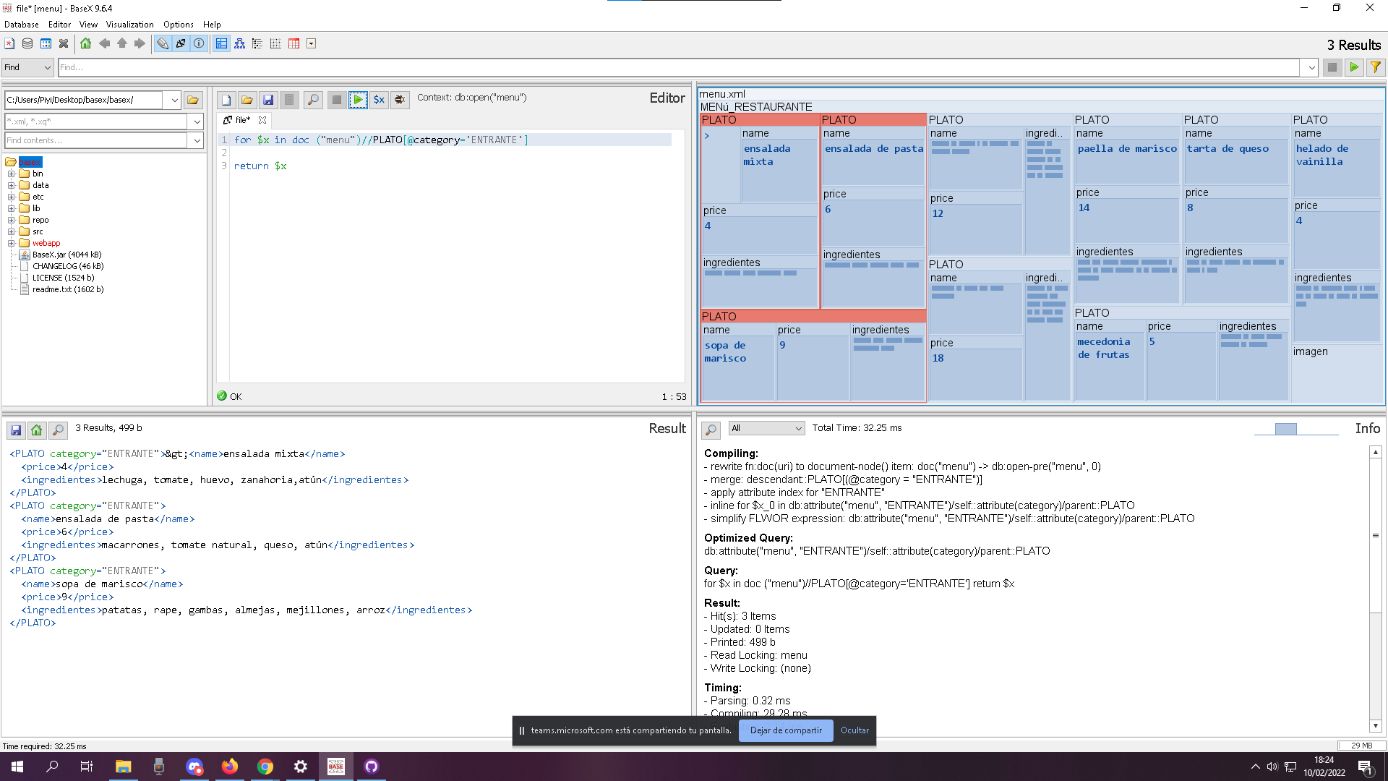

for $x in doc (“menu”)//PLATO[@category=’PRINCIPAL’]

return $x

